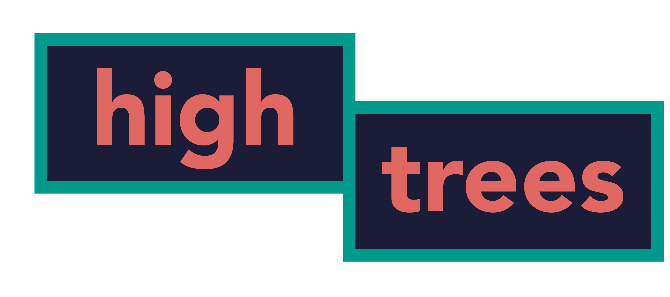
Position Applied for:

Section - this section is compulsory
Please complete the following section. The information will not be used as part of the selection process and will not be disclosed to the selection panel.

Forename(s): | Surname:
Title: Dr/Mr/Mrs/Miss/Ms/Other (Please state)

Section 2 - this section is voluntary
High Trees Community Development Trust is committed to a policy of equal opportunities in employment. To help us monitor the effectiveness of this policy it would be helpful if you would complete the following sections. The information will not be used as part of the selection process and will not be disclosed to the selection panel.

Sex

Female
Male

Age

Date of Birth

Ethnic Origin
Please tick a box from the list below which best describes the ethnic group to which you belong.

Asian or Asian British | Indian |  | Pakistani
 | Bangladeshi
 | Other Asian background. Please specify
Black or Black British | Caribbean |  | African
 | Other Black background. Please specify
Chinese or Other | Chinese
Ethnic Group | Other. Please specify
Mixed Race | White and Black Caribbean |  | White and Black African
 | White and Asian
 | Other Mixed background. Please specify
White | British |  | Irish
 | Other White background Please specify
Other Ethic Origin | Please specify

Sexuality

Heterosexual | Lesbian/Gay | Bisexual | Prefer not to say

Disability

Do you have any permanent or recurrent illnesses or disabilities? If yes, please specify. (A disability or health problem does not preclude full consideration for the job.)

